**Project Presentation**

# Introduction

For the 3rd Year Group Project, Imperial College students from the Electrical and Electronic Engineering Department are asked to conceive a solution to a problem that is presented by a Client, in teams of 6 or 7. Our team chose the Aftermarket ADAS project, from the ARM company. The team’s Client was Pete Harrod, and the supervisor John Wickerson.

**Project Brief**

As described by our Client, “the proposal is for the team to research, design and develop a car driver alertness sensing and warning device” (see Project Brief).

**Motivations**

The need for creating such a device arises from two major reasons:

* Security: 100 000 vehicles crash each year worldwide because of drowsiness, causing more than 1500 deaths according to the US National Highway Traffic Safety Administration (NHTSA)[1].
* Commercial Potential: The ADAS market is expected to reach $62,7 billions in 2024 against $27,5 in 2016[2]. This makes the conception of such solution interesting from an economical perspective.

**Team members**

Our team consisted of 6 Electrical and Electronic Engineering students:

* Valentin Gourmet
* Un Leong
* Kexin Li
* Wenjia Luo
* Zhengyu Wu
* Panyang Zeng

# Project Management

## Milestones

At the beginning, a Milestone Timeline was realized, to give a clear overview of how the project should be handled and tasks should be split, between the start of the project (30/04/2018) until its end (10/07/2018) (see Figure 1).

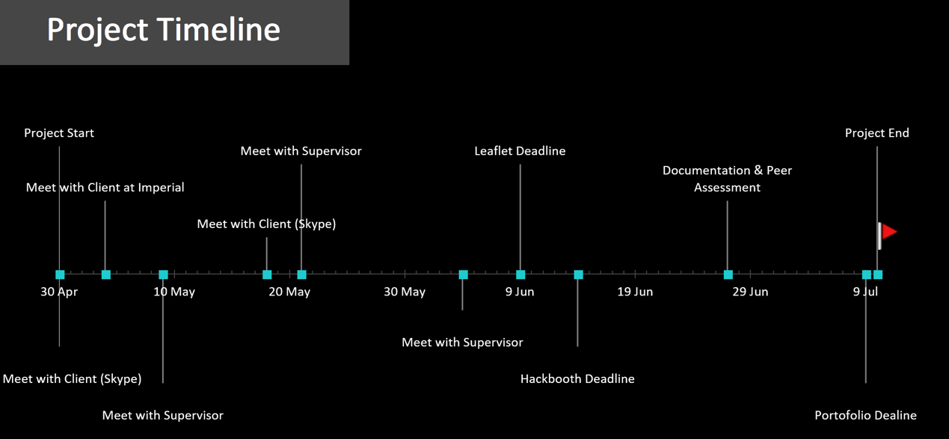

Figure 1: Project Timeline

## Gantt Chart

In addition, to ensure clear tasks were set all along the project, and to ease the clarity of everyone’s role and objectives, a Gantt Chart was initially established and was completed every two weeks. This helps to better understand the flow of the whole project. (see Figure 2) An enlarged version will be provided in the Appendix.



Figure 2: Project Gantt Chart

Sources and References

[1] <https://www.nhtsa.gov/sites/nhtsa.dot.gov/files/rau.pdf>

[2]<https://www.weforum.org/agenda/2016/04/the-number-of-cars-worldwide-is-set-to-double-by-2040>

**Appendix**

2018 Third Year Industrial Group Project Brief

|  |  |
| --- | --- |
| **Name of Company** | Arm |
| **Contact Details** of company representative/supervisor(s) | Name: Pete Harrod  Email: pete.harrod@arm.com  Tel: 01223-400473 |
| **Introduction to Company** | Arm is one of the leading suppliers of microprocessor and SOC infrastructure IP, together with associated software products. Arm licenses its IP to semiconductor companies worldwide and earns royalties on each unit sold. Through its partnerships with leading companies, Arm has built a complete ecosystem for hardware and software development. Arm’s IP is used in a diverse range of products, ranging from all kinds of mobile devices, through embedded applications such as automotive systems to high end applications like servers. It is a major player in the burgeoning Internet of Things market. |
| **Project Description**  Describe the problem to be solved by the project team giving as much details as possible. | The proposal is for the team to research, design and develop a car driver alertness sensing and warning device. As more and more driver assistance systems become commonplace, there may be a tendency for drivers to not pay full attention to their surroundings and what is happening on the road ahead. They may be tempted to take their eyes off the road and start reading text messages or social media, or even to fall asleep. As partial or fully autonomous driving systems appear, it will still be important for the driver to remain alert so that control can be passed back to the driver when the system is unable to process the signals it is receiving, when a fault occurs or when some other emergency situation arises.  It is expected that the device will be built around an embedded processor, with interfacing to a sensor of some kind. Software to control the device and interact with the user will be required.  The team should consider the market for this device and pitch its price, performance and power consumption to suit the application. For the purposes of this project, it should be assumed that this would be available as an after-market product – i.e. not one that is fitted as standard equipment when the car is new. |
| **Commercial/Industrial context** for project | An application of embedded hardware and software to meet a product need in the automotive safety market. An international standard, ISO 26262, sets out requirements that a project should follow if it is has a functional safety application in the automotive space – and the team should gain some awareness of this standard. |
| **Challenges** – technical and professional | Carry out some market research to determine the requirements for this product and find out what competing products are already available. The challenge will be to design a product that meets the brief but that is also compelling. Ideally a prototype should be built that can demonstrate at least some basic functionality. |
| **Roles/Expertise/Skills required** i.e. any particular skills that would be essential/desirable | Knowledge of microprocessors and embedded hardware and software |
| **Resources** available:  £ in excess of £500  Personnel  Equipment | An Arm Mbed could be made available  Access to Arm staff |

